C:\Users\wearyca\Desktop\FCEC Logo.png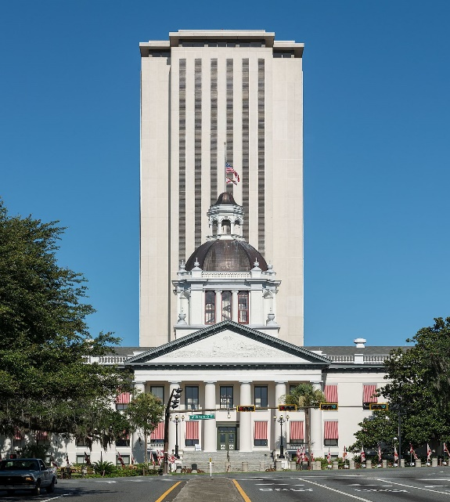 

Virtual Florida Special Education Advocacy Legislative Summit

Florida CEC SEALS

Join us for a 3 part series on Florida policy and advocacy around special education. Connect with other educators for a free informative training to gain knowledge on the Florida legislative process and how to advocate for teachers and students.

Topics, Dates, & Times

**Florida CEC SEALS Day 1-February 23, 2021, 6:00 pm -7:00 pm**

Welcome and Introductions

Karen Ramlackhan, PhD., Florida CEC President

Overview of the Florida Legislative Process

Bob Cerra, Advocacy Specialist

C.A.S.E. Updates (Council of Administrators for Special Education)

Lynne Mowatt, CASE Legislative Chair

Washington Legislative Update

Angela Weary-Crooks & Taryn Wade, Florida CEC Advocacy

Registration Link

[https://us02web.zoom.us/webinar/register/WN_qJrizAUnQEiRvQeF8TG_jA](https://nam04.safelinks.protection.outlook.com/?url=https%3A%2F%2Fus02web.zoom.us%2Fwebinar%2Fregister%2FWN_qJrizAUnQEiRvQeF8TG_jA&data=04%7C01%7Ckarenr1%40usf.edu%7Ce9b0791278464fd38f2f08d8c2de2167%7C741bf7dee2e546df8d6782607df9deaa%7C0%7C0%7C637473606589538632%7CUnknown%7CTWFpbGZsb3d8eyJWIjoiMC4wLjAwMDAiLCJQIjoiV2luMzIiLCJBTiI6Ik1haWwiLCJXVCI6Mn0%3D%7C1000&sdata=NBfr%2FEE3AywH6HepAyVFySjB66FB567Z9OwbWQp%2BBMA%3D&reserved=0)

**Florida CEC SEALS Day 2-February 25, 2021, 6:00 pm -7:00 pm**

Informational Session on Florida CEC’s Issue Briefs

* Eliminate Dangerous Practice’s with Restraint/Seclusion

Shannon Lesperance, HCPS ESE Assistant Director Instructional Programs and Equity

* Ending Corporal Punishment in Florida Schools

Angela Weary-Crooks, Florida CEC CAN Representative

* Improving Equitable Outcomes in the Least Restrictive Environment,

Karen Ramlackhan, PhD., Florida CEC President

* Diversity in the Workforce

Lynne Mowatt, CASE Legislative Chair

Registration Link

[https://us02web.zoom.us/webinar/register/WN_t2ZXqIN6TBC7NbBJlSFWhg](https://nam04.safelinks.protection.outlook.com/?url=https%3A%2F%2Fus02web.zoom.us%2Fwebinar%2Fregister%2FWN_t2ZXqIN6TBC7NbBJlSFWhg&data=04%7C01%7Ckarenr1%40usf.edu%7Ce9b0791278464fd38f2f08d8c2de2167%7C741bf7dee2e546df8d6782607df9deaa%7C0%7C0%7C637473606589548591%7CUnknown%7CTWFpbGZsb3d8eyJWIjoiMC4wLjAwMDAiLCJQIjoiV2luMzIiLCJBTiI6Ik1haWwiLCJXVCI6Mn0%3D%7C1000&sdata=O8rNX2TYX7tF%2BDISxR1k18hiwiK3BfmOYQp6xr%2BJ%2Fkg%3D&reserved=0)

**Florida CEC SEALS Day 3-February 27, 2021, 10:00 am -11:00 am**

Preparing to meet with your Legislators

Taryn Wade, Florida CEC Information Specialist

How to Stay Involved and Continue to Advocate

Angela Weary-Crooks, Florida CEC CAN Representative

Lynne Mowatt, CASE Legislative Chair

Registration Link

[https://us02web.zoom.us/webinar/register/WN_gwMPaWn2ThmLWN2Z2nnc-Q](https://nam04.safelinks.protection.outlook.com/?url=https%3A%2F%2Fus02web.zoom.us%2Fwebinar%2Fregister%2FWN_gwMPaWn2ThmLWN2Z2nnc-Q&data=04%7C01%7Ckarenr1%40usf.edu%7Ce9b0791278464fd38f2f08d8c2de2167%7C741bf7dee2e546df8d6782607df9deaa%7C0%7C0%7C637473606589548591%7CUnknown%7CTWFpbGZsb3d8eyJWIjoiMC4wLjAwMDAiLCJQIjoiV2luMzIiLCJBTiI6Ik1haWwiLCJXVCI6Mn0%3D%7C1000&sdata=kKK10LO43pgneCirGinNl5PLxd0gmNGo41c0TpZH8X4%3D&reserved=0)

Email questions to: [fcecadvocacy@gmail.com](mailto:fcecadvocacy@gmail.com)

**Free**